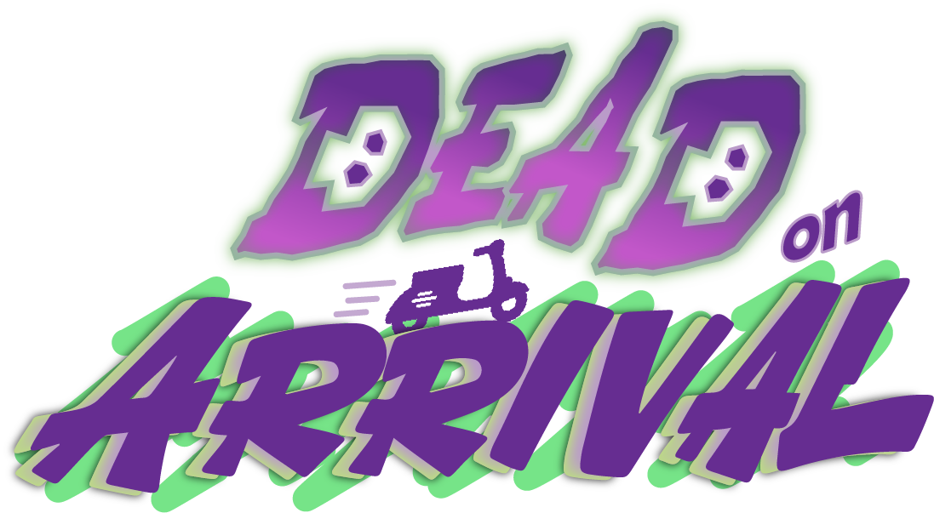
Game Design Document
November 2026 | Version 3.0 | The Boo Crew

Table Of Contents
Elevator Pitch
Document Status
Genre
Target Audience
Platform
Target Length
Game Concept
Pillars
Navigation
Competition
Arcade Driving
Design Goals
Mechanics
Driving
Phase Boost Mechanic
Drifting
Stealing
Respawning
Orders
Waves
Game Modes and Match Rules
Modes
Match Rules
CPU Rivals
Controls
Game Loop
Level Design
Map Size/Shape
Map Direction
Main Area Design
Final Area Design
Tutorial Area
Map Borders
Multiplayer
Local Play
Online Play
Player Interactions
Winning
Losing
After the Match
UI
HUD
Menus
Accessibility and Language
Emotes
Steam Features
Cinematics
Sound Direction
Audio Asset List
Project Scope
Production
Status
Risk Analysis
Revision History

Elevator Pitch
Imagine a fast-paced, multiplayer game where you're not just racing against the clock, but also against three fierce competitors. Welcome to Dead on Arrival, the ultimate delivery driver showdown! Set in Necropolis, a spooky ghost city, you pick up and drop off orders on a souped-up scooter, phase-boost through buildings, and slam into rivals to steal their deliveries, all to become the top driver. Play split-screen on one couch, online over Steam, or solo against CPU rivals.
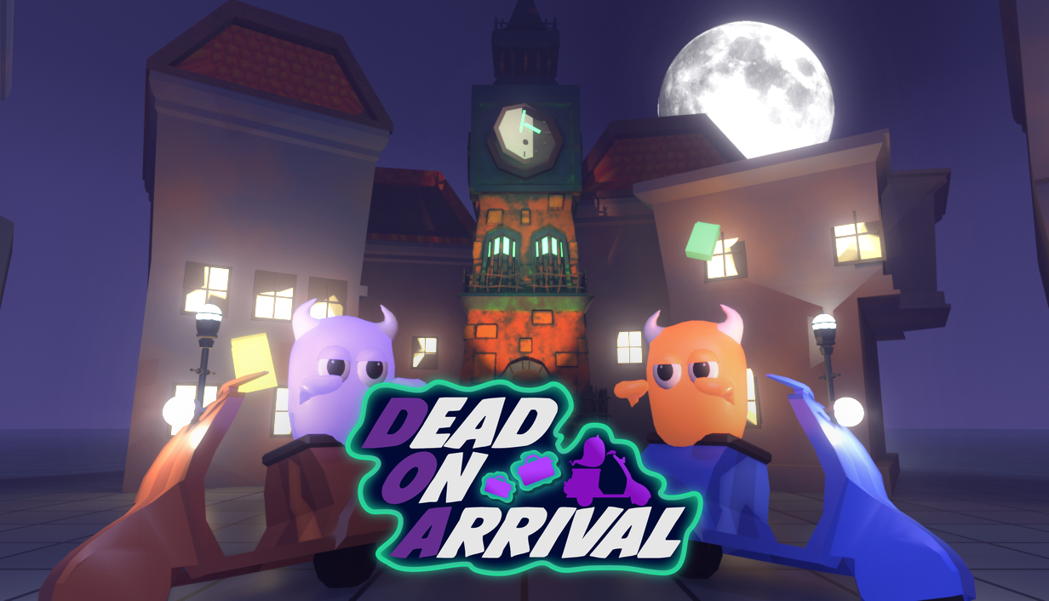
(Fig 1. Current key art, also used as the Steam main capsule)

Document Status
This document describes the game as it stands today, not the 2023 capstone plan. It covers what the player sees and why. How each thing is built is in the separate Technical Design Document (TDD). Features still waiting on a hand playtest are marked in Project Scope.

Genre
- Dead on Arrival is a Multiplayer, Action, Racing, Party Game
  - Racing/driving should feel like Mario Kart 8
- Multiplayer split-screen and online

Target Audience
The target audience of Dead on Arrival is children/teens and fans of competitive couch games, plus groups of friends who play online together.
- Nintendo Mario games like Mario Kart and Mario Party would have a similar audience

Platform
- PC, on Steam (App ID 5553880), with full controller support
  - Windows is live on Steam and has been played from Steam
  - macOS and Linux builds exist but have not been played yet. They ship only once they have been
  - Steam Deck runs the game; it starts on Medium quality
- One player can use the keyboard, alongside up to three controllers. Menus also take the mouse
- The original itch.io plan was replaced by the Steam release

Target Length
A standard match lasts about 5 to 6 minutes. It has 3 waves of 60 seconds each, a short highlight reel, then a final round with a golden order. The final round has no time limit and lasts until the order is delivered. Match rules can change this: waves can last 45, 60 or 90 seconds, a match can have 1 to 6 waves, and the golden round can be turned off. Modes without deliveries run on a 2, 3 or 5 minute round timer.

Game Concept
- Dead on Arrival is a competitive multiplayer game in which up to 4 players race to pick up and drop off orders, earn money and be the most successful delivery driver.
- Each player can use drifting and a phase boost to battle their opponents. Phase boosting rapidly increases speed, steals other players' orders on contact, and lets the player phase through buildings.
- Stealing is rewarded: every steal makes the package worth more and pays the thief.
- New orders spawn in waves, with one final golden order at the end that players fight over to make a comeback or secure first place.

Pillars
The 3 main pillars of Dead on Arrival are navigation, competition, and arcade driving.

Navigation
Dead on Arrival focuses on player choice and lets players choose how they navigate the map and plan their approach. We foster this with many possible paths and routes, plus factors to take into account such as moving platforms, ramps, boost pads, grass that slows the scooter, water, and the ability to boost through houses. The compass says where things are, but the game does not show how to get from point A to point B: the player chooses the route. The game has portions of tight navigation where players need to drift and take sharp turns, and open areas to boost around in and brawl with opposing players.

Competition
Competition is a huge focus for this game and is inherently supported by the racing genre. Split-screen and online lobbies create social competitiveness between friends, who can steal from and hinder each other and then tease each other about it. The live scoreboard shows everyone's money and what they carry, a stolen package burns with a purple flame so everyone can see what's worth chasing, and the end of a standard game comes down to fighting over one golden order that increases in value over time. The highlight reel, award cards and rematch vote keep that rivalry going after the match.

Arcade Driving
There is an emphasis on arcade driving rather than simulated driving, meaning the game has an agile play style that lets the player move quickly and adapt to events. This comes from responsive, tight controls for the scooter. Other arcade-like abilities include a mini turbo after drifting, a slipstream behind rivals, and the phase boost.

Design Goals
Create a level that
- Has many traversal options
- Is intuitive
- Is concise
- Is interesting
- Is dynamic
Game must feel
- High octane
- Fun
Create rules that
- Make stealing worth the risk: 2024 playtests had 16 of 26 multiplayer matches with no steal, which led to the steal value rules
- Keep a full lobby possible at any time: CPU rivals fill empty online seats

Mechanics

Driving
- Players drive a scooter
- Players can accelerate forward, brake, reverse, turn left and right, drift, and use phase boost
- 3rd person camera
  - Full camera control as to where the player wants to look
    - Camera direction does not dictate what direction the player is moving
    - Camera follows the direction the player is driving when not actively controlled
  - A button swaps to the other camera view
- Responsive controls: the scooters have a satisfying and zippy feel, responding to every input
- Players should rarely feel like they need to heavily slow down or stop
- Accelerating to max speed should not take long, to further push the snappy arcade driving feel
- A slipstream behind each player gives a following player a slow speed gain, then a larger burst after 1.5 seconds tucked in
- Speed lines and a wider view sell the speed. The Reduce motion option turns them off

Phase Boost Mechanic
- Pressing the boost button accelerates the player quickly to a much faster speed with a wheelie. The boost lasts 1.6 seconds, then speed ramps back down to regular max speed
  - During the boost the player has limited turning (60% of normal)
  - Players can not be drifting and phase boosting at the same time. If boost is activated while drifting, the drift is cancelled and the boost takes place
- Players phase through buildings instead of colliding while the boost is active
  - While inside a building the player's view swaps to a separate phase view. This replaced the 2023 wireframe void idea, where testers lost track of where they were
  - If a player is inside a building when the boost would end, it extends just long enough to get them out. A player can never get stuck
- Hitting a rival who is not boosting steals from them (see Stealing)
- When two boosting players collide they bounce off each other. Nothing changes hands
- Plain bumps without a boost push the other player based on how fast the two closed
- The boost recharges rather than sitting on a fixed 10 second cooldown
  - 3 seconds with empty hands, 8 seconds while holding a package: carrying costs you your best weapon
  - The boost is available at the start of a match
  - The ghost's horns glow as it recharges and flash when it's ready

Drifting
- Drifting is performed by holding the drift button
  - Drifting lets the player turn tighter on corners without losing speed. A small hop starts it
  - There are 3 tiers, shown by the colour of the sparks. The longer the drift is held, the bigger the speed burst when it is released
  - Slowdowns such as grass do not apply for a moment after a drift boost

Stealing
- Boosting into a rival who isn't boosting takes their best order, if the thief has a free hand
  - The victim drops whatever else they carry on the ground, and anyone can grab it, including the victim
  - If the thief's hands are full they take nothing, and everything the victim held is dropped
  - The victim spins out and bounces away
- A steal makes a package more valuable
  - Its worth doubles each time it is stolen (an Easy order stolen twice pays 4x)
  - The thief is paid $7 at once, once per order per thief, even if they never deliver it. A bump that takes nothing pays nothing
  - A stolen package looks larger and burns with a purple flame
  - The golden order never doubles. Its worth grows with time instead
- Steals made in the tutorial don't double or pay. They only teach the move
- The STEALS match rule can turn all of this off. Boosting into a rival then still bumps them

Respawning
- Players respawn when they fall in the water
  - The player's ghost shows as a wisp, then rises from a gravestone on the nearest free respawn point, about 2 seconds later, facing away from the water
    - The gravestone can't be interacted with and crumbles away after a few seconds
  - Two players never rise from the same point
- Orders held when a player falls are dropped around the respawn point. The player can't pick them straight back up, which gives perceptive rivals a chance to grab them

Orders
- Orders are picked up from pickup locations around the map and dropped off at the dropoff location that appears on picking one up. Each player can carry up to 2
  - Each order has one set pickup and one set dropoff. A wave picks at random which orders are out
  - Pickup and dropoff locations have a small radius outside the buildings that the player drives through
    - An NPC ghost waits at each location, throwing the order onto the scooter or cheering a delivery
    - An arrow on the package points to its dropoff point
  - A dropoff glows only for the player holding that order
- Delivering pays the order's worth based on its difficulty, in 3 colours:
Order | Price | Route
Green (Easy) | $55 | Often short and simple
Yellow (Medium) | $65 | Longer
Red (Hard) | $80 | The most challenging routes
Golden | $50, rising | The final round only

Prices were set by simulating how long each tier takes to score, so a short Green delivery stays a good choice.
- The game has one special final golden order
  - It starts at $50 and rises $5 every 2.5 seconds while someone holds it
    - This keeps the final package important without making the rest of the game obsolete
      - The player in first is incentivised to deliver as fast as possible so no one else can catch up
      - Players behind can come back by holding it until it pays enough to pass first place
  - Its holder drives at 85% force, so rivals can catch them. Without this the leader could simply run away
  - The pickup is always in the same place, and the dropoff is in front of a mansion
  - No other orders are available during the final round
    - This focuses all players on one order and ends on a dramatic finish
- There are no other types of item pickups

Waves
- Each wave is 1 minute and a match has 3 waves by default
- Each wave allows a set number of each order out at once. A new one spawns every 4 seconds while there is room
  - The caps ramp from easy to hard, and were lowered in 2026 so players have more reason to steal:
Wave | Green | Yellow | Red | At once
1 | 1 | 2 | 1 | 4
2 | 1 | 1 | 1 | 3
3 | 0 | 1 | 2 | 3

  - Orders from earlier waves stay in play until delivered, or until the waves end
- When the last wave's timer runs out, a whistle blows and every scooter stops
- The highlight reel plays, if the round had moments worth showing
- The final round starts, at which point all other orders disappear from scooters and the map
  - This round has no timer and lasts until the golden order is delivered

Game Modes and Match Rules
Standard is the game as designed and balanced. The other modes and mutators are optional extras for fun, and the rules panel says so when one is on.

Modes
Mode | How it plays | How you win
Standard | Waves of deliveries, then the golden round | Most money
Gold Rush | 3x the orders, spawning every second. Your score drains $2 a second after 5 seconds without a delivery. In the last 30 seconds (rush hour) every steal counts twice. No drain in the golden round | Most money
Kings Crown | One crown starts on the road. Whoever holds it earns $10 a second and has 2 seconds of safety after taking it. Boost into the holder to take it | Most points at time up
Infection | A random first hunter catches thieves by boosting into them, and the caught join the hunt in the hunter's colour. Thieves earn $5 a second while free. Each catch pays the hunter $50 | Highest score. The round ends early when no thief is left
Hot Potato | A cursed package on a hidden 15 to 25 second fuse. The holder passes it by boosting into someone, with no tag-backs for 1.5 seconds. When it explodes, its holder is out and spectates. Everyone still in earns $10 a second | Highest score. The last player standing ends the round

Kings Crown, Infection and Hot Potato have no orders, no golden round and no delivery tutorial. Each is a single round on the Round Timer, then the usual reel and results. 2v2 Teams is still only an idea.

Match Rules
In player select or the online lobby, Start opens MATCH RULES. Only the player working the menus can change them. Online the host's rules run the match. A public lobby always plays Standard with the normal rules.
Rule | Choices | Default | Modes
Mode | The five above | Standard | All
Wave Length | 45 s, 60 s, 90 s | 60 s | Standard, Gold Rush
Waves | 1 to 6 | 3 | Standard, Gold Rush
Round Timer | 2, 3, 5 minutes | 3 minutes | Kings Crown, Infection, Hot Potato
Steals | On, Off | On | Standard. Locked on in Gold Rush, Kings Crown, Hot Potato. Hidden in Infection
Golden Order | On, Off | On | Standard, Gold Rush. Off goes straight to the results
Bots | On, Off | On | All (online only)
Speed | 50, 75, 100, 125, 150, 200% | 100% | All
Low Gravity | On, Off (half gravity for everything) | Off | All

CPU Rivals
- Online, empty seats fill with CPU drivers unless the host turns Bots off, so one player can play solo against three. Local Play has no bots
- Bots are named like people and have no labels. Players learn each personality by how it drives:
Personality | Behaviour
Thief | Goes after players to steal, the leader most of all
Hunter | Drives far for big packages. Steals big ones only when behind
Courier | Near, quick orders, boosts a lot, and swerves away from boosting rivals while it carries

- One bot is a thief, two are a thief and a hunter, three adds the courier
- All of them watch the scoreboard: they target the leader, and grow desperate as they fall behind
- Bots also play the three timed modes: chasing the crown or holder, hunting or fleeing, passing the potato. They don't count towards a cutscene skip vote

Controls
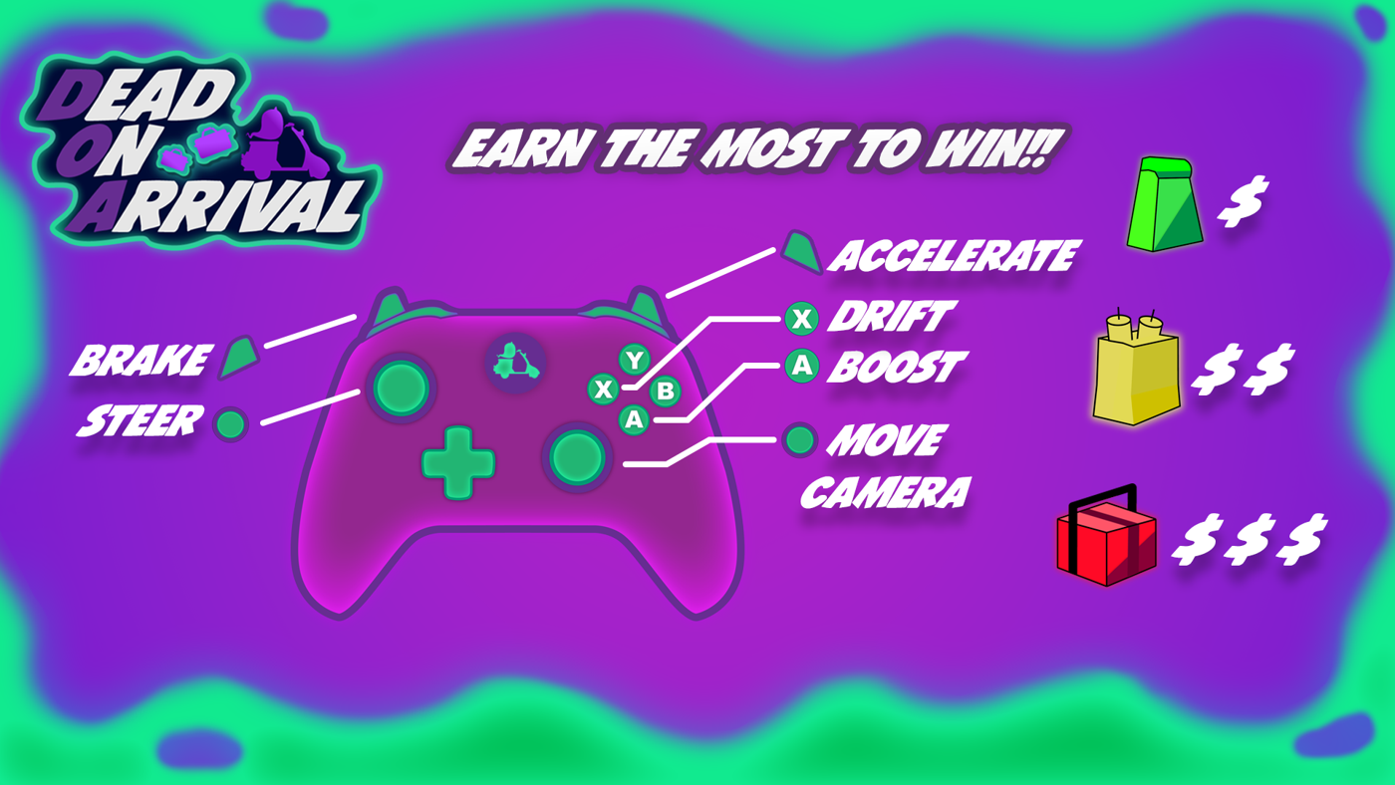
(Fig 2. Control scheme, as shown on the game's loading screen)
Action | Controller | Keyboard
Steer | Left stick | A / D or arrows
Accelerate / brake | Right trigger / left trigger | W / S or arrows
Boost | A (cross) | Space
Drift | X (square) | Left Shift
Turn the camera | Right stick | Q / E, Z / C
Swap the camera | Right stick press | Tab
Pause | Start | Escape
Menus: move / pick / back | D-pad or left stick / A / B | WASD or arrows / Space or Enter / Backspace
Lobby: customize | X (square) | Q
Lobby: invite or host | Y (triangle) | Tab
Lobby: find a match / open to anyone | Left / right shoulder | F / R
Skip a cutscene (vote) | Hold A half a second | Hold Space
Results: rematch / back to lobby | A / B | Space / Backspace

- Xbox, PlayStation and Switch Pro controllers are supported, and button prompts follow the device in use
- Every player can rebind driving controls from the pause menu. Sticks, Start and B are fixed
- The emote and leaderboard buttons from the 2023 plan are gone. The scoreboard is always on screen

Game Loop
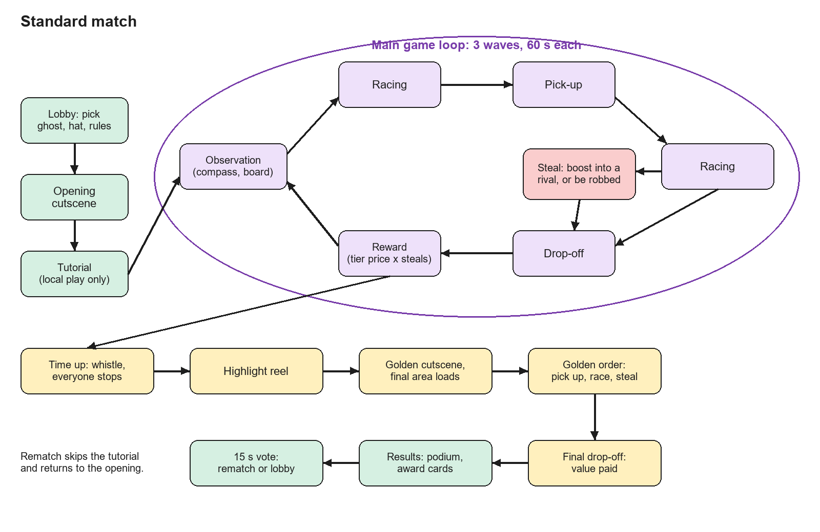
(Fig 3. Game loop for a standard match)

Level Design

Map Size/Shape
- The map is angular and surrounded by water
- It should not take the player more than 30-40 seconds of driving to cross half of the map, as the player should be able to make at least 2 deliveries per wave
- A separate final area holds a large mansion
  - The mansion is the drop-off location for the final golden order
  - The area is a separate level, loaded behind the golden cutscene, and does not connect to the main map
  - It has its own city-like layout, with stilt houses and boats

Map Direction
- The map is reminiscent of European streets, with thinner cobblestone streets, no sidewalks, and lots of alleyways (Fig 4)

(Fig 4. European street view, the original reference)
- We stay away from American style road features such as:
  - Wide roads
  - Gridlock patterns
  - Long straight roads
- The map has few dead ends so gameplay remains fluid
- The final area has long stretches for racing and stealing, with city areas where the golden order holder can weave and dodge
- Dynamic features make gameplay more unpredictable and encourage the agile playstyle:
  - Grass patches, which slow the player to 65% unless boosting
  - Moving platforms to get across water
  - Speed boost pads (14 in the main area, 15 in the final area)
  - Ramps
  - Pedestrians who get bumped and flung, then pop back
  - Kickable props such as tombstones, barrels, benches and cans
- The 2023 gates and moving cars are not in the game

Main Area Design
- The main area is Design Scene (Main), with 28 orders and 63 respawn points
- It has a market, canals, a graveyard, and a central square with fountain and clock tower
- Fig 5 is the original layout plan. The route structure still holds, but the built map has moved on from it in detail, and the gates are gone. The scene is the source of truth
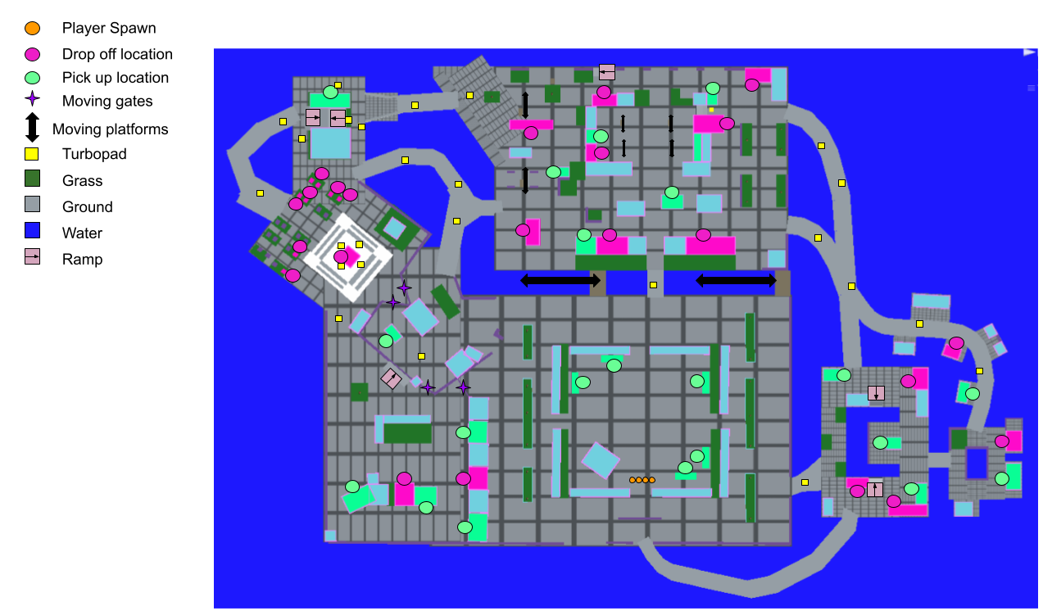
(Fig 5. Original main area layout plan, with legend (map version 2.0))

Final Area Design
At the beginning of the golden round the players are transported to the final area, which has 67 respawn points. It consists of long snaking roads and a small cityscape. The long roads are prime locations for racing and stealing. The cityscape is meant for the player with the golden order to kill time and let the order increase in value. It has tight corners and even a second layer players can use to their advantage.
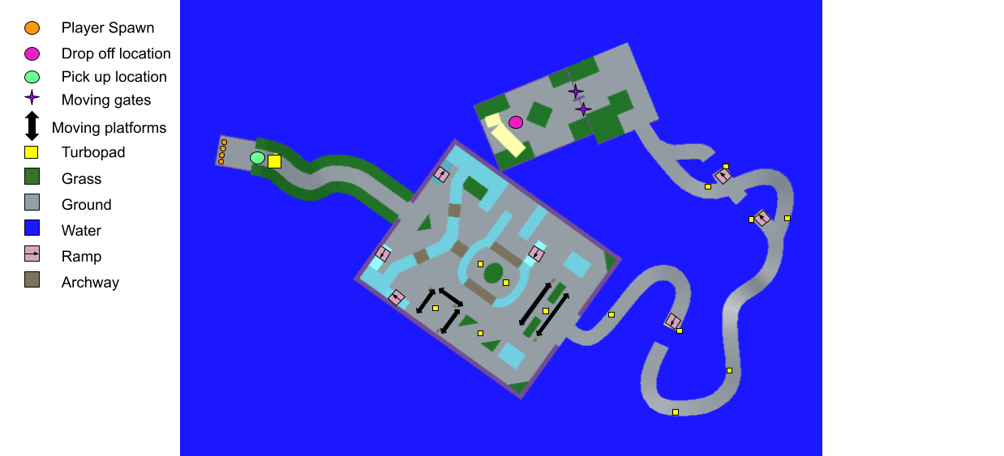
(Fig 6. Original final area layout plan, with legend)

Tutorial Area
- A local match begins with one tutorial lane per player: drive, pick up, deliver, then boost into a cardboard cutout to learn stealing, and drive out into the city
- The first wave starts once everyone has finished. Points earned there carry into the match
- The tutorial is skipped online (2026 playtest: it didn't suit the lobby loop), on a rematch, and in modes without deliveries

Map Borders
- The map is surrounded by water, which means the player can only drive where there is ground. Fog around the edges of the map keeps the player from viewing off into the infinite horizon.

Multiplayer

Local Play
- 1 to 4 players on one screen, one controller each, plus one keyboard
- Two players can pick boxed, stacked or side by side split-screen
- A controller lost mid-match pauses the game until it or another one takes over

Online Play
- Up to 4 players over Steam. No port forwarding, and no one sees another player's IP address
- The online lobby is Dispatch, a delivery depot room: each player has a podium and a ticket that reads HIRING, GETTING READY or DISPATCHED
- Lobbies are friends-only. Friends join through invites or Join Game on the Steam friends list
- Matchmaking is opt-in:
  - Find searches for an open lobby near you. With none, your own lobby opens to anyone
  - Fill opens your lobby to anyone, or back to friends only
  - An open lobby with two or more machines starts by itself after 60 seconds
- Nobody joins mid-match. A player who leaves is removed, with the match going on
- If the host leaves, everyone goes back to the title screen. There is no host migration
- Pausing doesn't stop an online match. The pause menu shows every player's connection
- Online is one player per machine for now. Couch players online are built but switched off
- Steam pictures and names are shown on the lobby, scoreboard and over rivals' scooters. There is no chat

Player Interactions
We want players to interact with each other rather than just splitting off and delivering orders without seeing other players.
- It is important to keep the orders available for pickup to a smaller number that requires players to fight over them
- The ability to steal orders is an important tool, so players can hinder others besides just bumping into them
- We want to evoke the same kind of feeling with stealing that the blue shell in Mario Kart does. That feeling of "haha got you" is a memorable moment that sticks with players after the game has finished
- We believe these interactions will not alienate our players but will amp them up

Winning
- The winner is the player with the highest score after the waves and the golden order (or at the end of the round in a timed mode)
  - If there is a tie for first place, the tied players share it

Losing
The remaining players are ranked on the end screen pedestal based on their scores.
- We show the remaining positions because the game is meant to be competitive

After the Match
- Highlight reel: after the waves, CCTV-style replays of the round's best moments, with captions. Players can vote to skip
- Podium and award cards: each player gets one joke award: Golden Grip, Kleptoghost, Busy Bee, High Roller, Butterfingers, Fish Food or Tourist
- Rematch vote: a 15 second vote per player. Once all have voted the rematch starts at once, keeping players and looks. Those who didn't vote go back to the lobby

UI

HUD
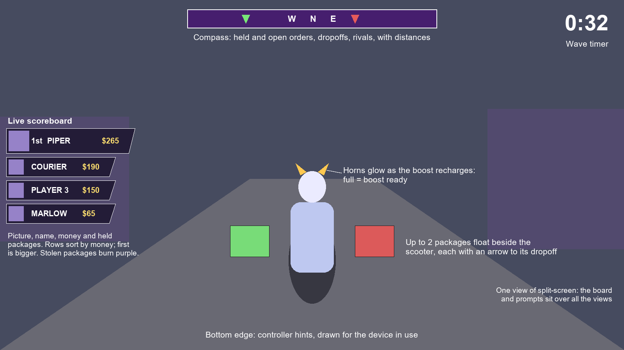
(Fig 7. HUD layout (a schematic, not a screenshot))
- The live scoreboard replaced each player's own score and placement display
- The minimap from the 2023 plan is not in the game. The compass does its job, and finding your own route is part of the Navigation pillar

Menus
- Dead on Arrival features several different screens
  - Title Screen
    - The game's logo and: Multiplayer, Local, Options, Credits, Quit. A flag shows the current language
  - Options Screen, on four pages turned with the shoulder buttons
    - General: music, effects, fullscreen, resolution, language
    - Display: fullscreen style, VSync, frame cap, quality, two-player split-screen
    - Audio: master volume, mute in the background
    - Accessibility: reduce motion, colourblind mode, text size
  - Player Select (local) and Dispatch (online)
    - Players pick a ghost colour (6) and hat (7, or none). Each seat has a delivery company with its own scooter colours: Ghostmates, DoorDeath, UberCreeps, SkipTheScare
  - Loading / Tutorial Screen
    - Shows the controls and order values with as few words as possible (Fig 2). A keyboard version and a golden round version exist too
  - Pause Menu
    - Resume, Restart (local only, with a confirm), Controls, Main Menu. Other players see PAUSED and their own Controls
  - End Screen
    - Shows all players' scores, names, award cards and the rematch vote
  - Credit Screen
    - Selectable only from the title. Shows the contributions of the Dead on Arrival team

Accessibility and Language
- Colourblind mode: safe ghost colours, plus a numbered shape badge per player over their scooter and on the board. A stolen package gets a "!" badge
- Text size: scales every UI text in the game
- Reduce motion: no boost FOV kick, speed-up FOV or speed lines
- 16 languages: English, French, German, Italian, Dutch, Spanish, Latin American Spanish, Portuguese, Brazilian Portuguese, Polish, Turkish, Czech, Romanian, Hungarian, Swedish and Danish. The first launch follows Steam's language. Translations are awaiting native speaker checks

Emotes
Emotes are not in the current game. The speech-bubble art and script from the capstone remain in the project, but no player has them and no button triggers them. Taunting today comes from the steals themselves, the horn flash and the highlight reel. If emotes return they need a design for online play and a new button, since the d-pad now has no in-match use.

Steam Features
Achievement | How to earn it
First Delivery | Deliver your first order in a match
Golden Finish | Deliver the golden order and finish first
Fresh Ghost | Finish the tutorial
Sticky Fingers | Steal an order from another courier
Grand Theft Parcel | Steal the golden order
Hard Mode | Deliver a hard order
Undertaker's Choice | Finish first
Last to First | Be last when the golden order appears, then win
Sleeping with the Fishes | Fall in the water

- Rich Presence shows friends what a player is doing (for example "Chasing the golden order")
- Steam Cloud syncs settings. Invites work from the friends list

Cinematics
- The first cinematic is the opening scene when players start the race
  - A camera pans in, then to the players' 3rd person views
- The golden cinematic plays after the regular waves, as the final area loads
  - A single full-screen camera shows the area and the golden order. Players start together, for an equal start
  - The 2023 fog-parting reveal was replaced: the final area is its own level, so there is no fog to part
- Both can be skipped: every human player holds A to vote. Bots don't count
- The highlight reel plays after the waves (see After the Match)
- Ending scene for leaderboard/pedestal
  - Players are shown with their scooters on a pedestal in final order, with names
  - A single camera shows the pedestal, with dance poses so it's not static

Sound Direction
The game should have fun, cute-sounding noises that fit the general tone of the characters and world. It should be soft and non-threatening. Online, other players' sounds fade with distance from your scooter: full within 10 m, silent from 60 m.

Audio Asset List
Sound Effect List
- Music: menu theme, main theme, final theme and results theme
- 14 placeholder sounds from the project's TEST folder still play in the game and need replacing before release (LICENSES.md)

Project Scope
In the game today
- 1 to 4 players: split-screen, or online over Steam (friends or matchmaking)
- Main map, final area and tutorial
- 4 delivery companies with their own logos and scooter designs
- Boost mechanic (phasing through walls/order stealing), with steal value
- Point system and order difficulty levels
- 5 modes and 9 match rules
- CPU rivals with 3 personalities (online)
- Live scoreboard, highlight reel, award cards and rematch
- Player-chosen ghost colour and hats
- 9 Steam achievements, Rich Presence, 16 languages, rebinding and accessibility options
- Music and SFX
Built, waiting on a hand playtest
- Highlight reel, bot personalities, live scoreboard online
- Mutators, Gold Rush, Kings Crown, Infection, Hot Potato
- A full solo match through Steam
Open design decisions
- Steal doubling has no practical cap. An agent playtest ran a package to $640 with half the orders out. "Normal density plus one doubling" played best
- The golden round has no time limit, and bots have carried the golden order into the water
- Timed modes have no scoreboard icon for the crown holder or who is infected or out
- Company names and logos are parodies, pending legal review before release
Stretch Goals
- Team mode (2v2)
- Additional maps
- Additional delivery companies
- Additional music tracks
- Item pickups
- Emotes
- Keyboard prompts everywhere

Production

Status
- The 2023-24 capstone by The Boo Crew is being released commercially on Steam, which needs every original contributor's IP sign-off
- Store page, Steam Input default and supported-feature settings still need finishing

Risk Analysis
Release may fall behind due to the following factors:
- Features built but not yet hand-tested fail in real play, especially online and the new modes
- Machine-written translations and placeholder sounds aren't replaced in time
- Licences, contributor sign-offs or parody names block release (LICENSES.md)
- The macOS and Linux builds turn out not to work. The macOS build is unsigned
- Players don't enjoy it or find it boring. Playtesting remains the answer to that

Revision History
Version | Date | Change
1.0 / 2.0 | November 2023 | Capstone design document (IASC 4F03)
3.0 | November 4, 2026 | Brought up to date with the Steam build: online play, bots, steal value, modes and mutators, new prices and caps, new UI, accessibility, languages, Steam features. Removed or marked what is no longer in the game (minimap, emotes, wireframe view, gates, cars, fog reveal)

